Project/Model: _Hourmeter project_ Project Leader  **Eng. Rafael Garcia**

|  |  |  |
| --- | --- | --- |
| **REV** | **Date** | **Description of change** |
| 00 | 6/12/2019 | Hour meter project New tester |
| 01 | Insert Date | Description of revision change |

Contents

1. SCOPE 3

1.1 PREFACE. 3

2. GENERAL PROCEDURES 3

2.1 QUOTATION 3

2.2 ACCEPTANCE 3

2.2.1 Equipment Review 4

2.2.2 Dry Run 4

2.2.3 Measurement Systems Assessment 4

2.2.4 Runoff at Seller’s Facility 4

2.2.5 Runoff at Buyer’s Facility 5

2.3 PROJECT MANAGEMENT REQUIREMENTS 5

2.4 DOCUMENTATION. 6

2.5 GENERAL DESIGN GUIDELINES. 7

2.6 GENERAL TECHNICAL DATA 7

2.7 MAIN COMPONENTS. 7

Frame design. 7

2.8 FRONT CONTROLS 8

2.9 PC’s CHARACTERISTICS 8

2.10 MECHANICAL DESIGN. 10

2.11 PNEUMATICS. 10

2.12 ELECTRICAL 11

2.13 PLC, DEVICES AND SOFTWARE. 13

2.14 ERGONOMICS SAFETY AND HEALTH. 14

3. ACTUALLY TEST PROCEDURE 15

3.1 EQUIP LIST 15

3.2 CONECTION SETUP 15

3.3 SCOPE AND POWER SUPPLY SETUP 15

3.4 TEST STEPS 15

4. TEST PROPORSAL 1ST TEST 16

5. TEST PROPORSAL FOR CLOSED PRODUCT (FINISH GOOD) 18

Instructions:

Please insert all your information into the Highlight in blue.

After modifications, be sure to remove all figures example, un-highlight all variables and update Content Table.

All information non-highlight is considered as statemen to Honeywell, thus will impossible to modify.

Any deviation will be accepted if all project team agree whit that.

# SCOPE

## PREFACE.

This specification has been written to present HONEYWELL requirements for industrial equipment in an orderly manner.

This specification is not intended to limit or inhibit development in industrial equipment design. Functional design of equipment shall be the complete equipment supplier’s responsibility. Deviations will be allowed when necessary agreed upon in writing by Manufacturing Engineer.

# GENERAL PROCEDURES

## QUOTATION

* All production machinery shall comply with this **Machinery and Equipment Specifications**.
* The following statement: “We agree to conform to this Honeywell Machinery and Equipment Specifications” shall be included on quotation.
* Quotation also shall include:
* Project and machine name
* Document reference number used for quoting (found on header of document)
* Manufacturing Engineer responsible
* Shall be accurately described by proposal drawings and explanations text. Data on obtainable production rates, estimated power supply, maximum time for changeover system, etc.
* Price for basic machine
* Price for required options
* Installation and start-up in Honeywell Juarez plant
* Planning schedule for delivery time and start-up of the station.
* Documentation required (see §2.5)
* Training to maintenance personnel at least as minimum of 8 hours (see §2.4)

## ACCEPTANCE

* The machine drawings shall be sent to Honeywell Juarez or should be scheduled a meeting to the supplier’s site or in Honeywell Juarez plant for pre-approval before to start the manufacturing and final approval to complete the manufacturing. Two official design review phases are required and mandatory. See §2.3.
* Preliminary machine acceptance is carried out on supplier’s site. This activity will be agreed with Honeywell Juarez before approval for machine shipment.
* All requirements detailed in the list of specifications and additions on purchase order shall be complied during preliminary machine acceptance.
* Machine will be checked at start-up in Honeywell Juarez MX plant as compliance to specifications using pre-acceptance checklist
* Machine final acceptance is carried out after integration of the station into the assembly line.
* After installation and set-up of machine by supplier will be attended a pre-validation test in Honeywell Juarez MX plant.
* For final acceptance of the machine, if nothing different is specified, a production period for acceptance is 3 complete production weeks without any problem.
* **Machinery will be Accept under follow concepts:**

## Equipment Review

Members of the buyer equipment acquisition team shall be present at the seller’s facility to assess the equipment for proper compliance to buyer specifications. Machine functionality shall be checked for such items as:

* Safety (lockout-tag-out, pinch points, shields, fail safes, etc.)
* Ergonomics
* Cycle time
* Uptime
* Noise level certification
* All systems functions (electrical, hydraulic, pneumatic, lubrication, etc.)
* Changeovers
* Fault/Error and Estop Recovery

## Dry Run

Prior to issuing the purchase order agreement, the buyer’s project engineer shall determine if a dry run is necessary. Some projects that are large in scope can be difficult and costly to set-up in a dry run mode, and therefore may be skipped at the buyer’s discretion. However, if minimal effort is required, a dry run of at least 8 hours at production speeds is recommended.

## Measurement Systems Assessment

Gage capability studies shall be conducted jointly by buyer and seller and shall be complete prior to the runoff at seller's facility. All gage capability studies shall follow Honeywell Gage Repeatability and Reproducibility. The buyer shall provide the seller with a copy of the gage capability spreadsheet used to evaluate the Gage Repeatability & Reproducibility (R&R) upon request.

All gages shall be calibrated and meet the following capability requirements:

* All variable gages shall have less than 10% tolerance R&R.
* All attribute gages shall 100% correctly identify all parts.

All gage masters:

* Shall have design approval from buyer prior to release for build.
* Shall be dimensionally checked and approved by buyer prior to performing the gage capability studies.
* Shall have gage number permanently affixed.

**NOTE:** If Honeywell Juarez Engineering Department, share or supply the complete **Test System**, **Measurement System Assessment** will not be considering.

## Runoff at Seller’s Facility

The equipment shall successfully complete a capability study and run at rate trial at the seller's facility before the equipment can be shipped to buyer. If possible, buyer personnel should be used to perform station manual operations and set-up functions on the line during the runoffs at the seller's facility.

The Manufacturing engineer shall specify the length of the run at rate trial. A minimum run of eight (8) hours is recommended in the absence of extenuating circumstances that would dictate a shorter trial. The buyer reserves the right to require that the equipment run different product models during the run at rate, depending on the availability of parts. The equipment shall meet the following requirements at the completion of the run at rate:

* All individual station characteristics that are monitored (i.e. SPC) shall be in control and have a Cpk ≥ 2.
* All parts unloaded as good parts shall meet buyer part specifications. If a non-conforming part is produced, the seller shall identify and document the reason(s) and restart the runoff.

Any losses (scrap, downtime, and productivity) shall be documented with a corrective action plan to rectify. All modifications to programming or equipment shall be documented and provided to the buyer at the runoff at the buyer’s facility.

All perishable or adjustable tooling changes are to be performed at least twice during this period by **Honeywell Juarez** production personnel. All safety devices and systems are to be deliberately exercised throughout the runoff.

## Runoff at Buyer’s Facility

The equipment shall once again successfully complete a capability study and run at rate trial at the buyer’s facility after the equipment is shipped and installed. The project engineer shall specify the length of the run at rate trial. A minimum run of eight (8) hours is recommended in the absence of extenuating circumstances that would dictate a shorter trial. The buyer reserves the right to require that the equipment run different product models during the run at rate, depending on the availability of parts. The equipment shall meet the following requirements at the completion of the run at rate:

All individual station characteristics that are monitored (i.e. SPC) shall be in control and have a Cpk ≥ 2.

All parts unloaded as good parts shall meet buyer part specifications. If a non-conforming part is produced, the seller shall identify and document the reason(s) and restart the runoff.

Any losses (scrap, downtime, and productivity) shall be documented with a corrective action plan to rectify. Any modifications to programming or equipment shall be documented and provided to the buyer.

All perishable or adjustable tooling changes are to be performed at least twice during this period by **Honeywell Juarez** production personnel. All safety devices and systems are to be deliberately exercised throughout the runoff.

## PROJECT MANAGEMENT REQUIREMENTS

* + 1. **Initial Design Review Meeting**. After releasing a purchase order, a design review meeting will be agreed and take place at **Honeywell Juarez**, vendor’s office or Teleconference. The purpose of this meeting is to allow **Honeywell Juarez** engineers to review details of system design that were not previously available and to provide the vendor an opportunity to get any additional information he might need. At the end of this meeting, the vendor should be able to move ahead at full speed with final designs to finish the project. At this meeting, the vendor shall supply a program control document, including a Gantt chart, detailing the milestone that is met to complete the project on schedule.

2.3.2 **Final Design Review Meeting**. A final design review will take place at **Honeywell Juarez**, at supplier’s site or Teleconference. The primary purpose of this review is to go over the PLC/LV/C# programming section and the product tools and machine design to make certain that the product will properly handle.

2.3.3 **Subsequent Working Meeting**. It is recognized that, since **Honeywell Juarez** intends to take delivery on a completely functional system, the vendor will require both technical assistance and multiple product samples to debug the PC/PLC programs and the hardware. Therefore, the necessity of working meetings with knowledgeable Manufacturing Engineers is obvious. The time and place of these meetings will be arranged as needed.

2.3.4 **Project timing.** It is the responsibility of the supplier to provide and maintain a project time line and tracking system. Note: Desirable time project no more than 14 Weeks.

* + 4. **Training**

Training for the maintenance personnel shall occur during or immediately after system installation. The course should cover an overview of the documentation, safety guidelines, troubleshooting and replacement of system components and scheduled maintenance plan. These classes should be held at **Honeywell Juarez** facility for a minimum of 5 Days. Software training should occur as well and it consists of an overview of the system architecture and description of how this project was implemented. The class will be attended by software development professionals and should be taught on that level. These classes should be held at **Honeywell Juarez** facility for a minimum of 5 Days. It is required to cover totally two days of full training as explained.

Deviations will be allowed when necessary agreed upon in writing by Manufacturing Engineer.

## DOCUMENTATION.

* The use of English language is mandatory on all papers, documents and machine labeling. This includes support equipment located on machine (i.e. measuring devices, dressing attachments, etc.).
* Two (2) sets of hardcopy documents and CAD drawings (.dxf, .step, etc.) in electronic format shall be submitted to the Manufacturing Engineer along with the machine. All documents shall be updated within 15 days after final acceptance and sent to the Manufacturing Engineer. These documents to be included are as follows:

1. Bill of materials for:

- All purchased components (including brand name, part number, supplier’s name and phone number)

- Manufactured (tooling) parts.

1. Machine working parameters and applicable operating range (i.e. working pressure, temperature, speed, etc.)
2. Operator Manual and Safety instructions.
3. Spare parts list (all items likely to be needed within one year).
4. Pneumatic diagrams.
5. Electrical diagram – including internal circuit diagrams, KVA ratings, fuse amperages, parts list, general diagram on installation position and panel diagram.
6. PC/PLC programs – program printout, symbol table and cross reference table in that order. As well as all programming comments required for debug and troubleshooting purposes.
7. Software CD’s, including source codes.
8. Computer program listings and flowcharts.
9. Troubleshooting guidelines table.
10. Assembly and detailed mechanical drawings of all the parts (all information required to be able reproduce any tooling/part on the machine).
11. CAD files
12. Preventive Maintenance (recommended activities, description & frequency).
13. Certificates of compliance (pressure vessel, calibration, high freq., etc.) of all applicable components.
14. Technical information (all information related to purchased parts: operation manuals, installation and set-up instructions, etc.).

All documentation shall be in English language.

The above listed documentation shall be release no later than 15 days after the machine installation.

Deviations will be allowed when necessary agreed upon in writing by Manufacturing Engineer.

## GENERAL DESIGN GUIDELINES.

**NOTE TO SUPPLIER: Machine’s design shall be done following this ME spec’s and approved by Honeywell Juarez-ME Forward Engineer responsible for this document. No construction is allowed without this approval. Correct functionality of equipment is the complete responsibility of supplier as well as any additional costs for corrections or changes required to equipment due to design, construction or other mistakes that are not in compliance with this spec’s document.**

## GENERAL TECHNICAL DATA

|  |  |  |  |
| --- | --- | --- | --- |
| **Mechanical** | | | |
| (L x W x D) | M | **Insert Overall Dimensions** |  |
| Weight | Kg | **Insert total weight** |  |
| **Production Technical Specifications** | | | |
| Cycle time (@ Efficiency) | sec | Insert Reference Point or Cycle time number |  |
| **Machine Controls** | | | |
| PLC and PC Types |  | See §2.9 |  |
| **Pneumatics** | | | |
| Type |  | SMC (see features below) |  |
| Input air Pressure | PSI | 80 – 120 |  |
| Functions (standard) | PSI | 90 |  |
| **Others** | | | |
| Noise Emission (DIN 45635) | dB | < 80 |  |
| Color (standard – alternative see Spec.) | RAL | RAL 9002 |  |
| **Machine connection** | | | |
| Pneumatic | mm | 6-8-12 |  |
| Pneumatic Pressure | PSI | 90 |  |
| Electrical |  | 120 VAC – N – GND – 60Hz |  |
| Power Consumption | KW | Insert KW |  |
| Data Interface |  | Ethernet |  |
| **Ambient Conditions** | | | |
| Ambient temperature | °C | (10-37) ºC |  |
| Humidity (no Condensation) | % | (10-85) % |  |

## MAIN COMPONENTS.

### Frame design.

* The frame is made by Welded Steel or Extruded Aluminum structure.
* Frame is equipped by anti-vibrations leveling components (If is required).
* Cold marking devices. To cold marking the Switch Case if good part at the end of the cycle. Number and positions of cold marking devices shall be accordingly to all the models to be processed. Cold marking devices positions will be agreed and approved by Manufacturing Engineer.
* Machine design: The supplier will verify during the design development if will be possible to respect this requirement or will be needed to propose a fixtures changeover concept. The concept will be proposed by the supplier in the quotation to respect the max. Machine dimensions allowed and to have the lower model changeover time. Concept will be agreed and approved by Manufacturing Engineer.

**Note: All fixtures, tooling and setups changes, will be performance in 10 min or less.**

* Easy maintenance and cleanliness



Parts that need be cover with paint shall be of color code:

**NOTE TO SUPPLIER: Machine dimensions and concept shall be shared, discussed and approved with Honeywell Juarez ME Engineers during both Initial and Final design review meeting (see §2.3). No construction is allowed without this approval.**

## FRONT CONTROLS

**Control Panel**

* The HMI will be integrated in the front panel.
* The HMI will be the interface between station and operator.
* Through its programming the operator can set-up the machine set-up.
* Through this panel will be possible to set-up the tools change over.
* This panel shall have all the buttons present to enable the main functions.
* These buttons can be integrated in the panel as touch or external.

**OPTION 1 Desired LENOVO** **60E9MAR1US TOUCH SCREEN (Industrial Type)**

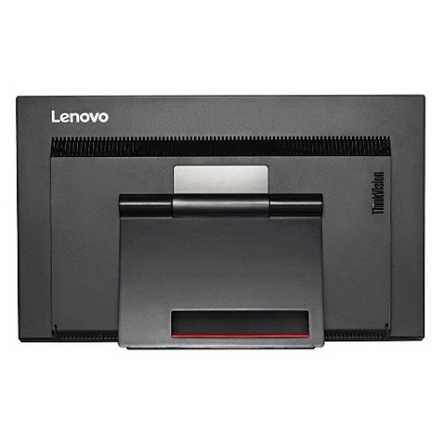

**Example of PC screen**

**OPTION 2 Desired Allen Bradley Panel View Plus 7 Graphic Terminals**

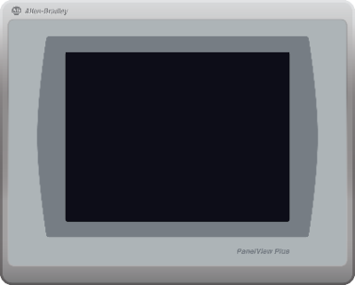

**Example of Panel View**

## PC’s CHARACTERISTICS

**OPTION 1**

ADVANCTECH PC industrial fan less, with **Windows 7 64 bits.** Computer **minimum** requirements are listed below

* ARK 3500-(2) PCIe slots
* CPU Processor Intel® Core™ i5/i7 Processor
* 8 Gb Minimum
* **Windows 7 Professional English 64bit (Includes Windows 10 Pro License)**
* AC/DC Adapter, 19v/6.3A 120W
* Solid state SATA III Internal SSD 128 Gb (2x if RAID is required)

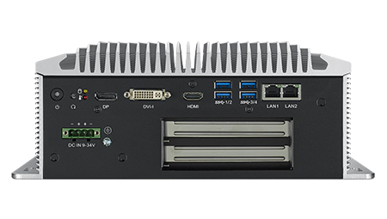

**OPTION 2**

ADVANCTECH PC industrial Rack mount, with **Windows 7 64 bits.** Computer **minimum** requirements are listed below

* ACP 4000
* CPU Processor 6th Generation Intel® Core™ i5/i7 Processor
* 8 Gb Minimum
* **Windows 7 Professional English 64bit (Includes Windows 10 Pro License)**
* Solid state or Magnetic SATA III Internal SSD 128 Gb (2x if RAID is required)

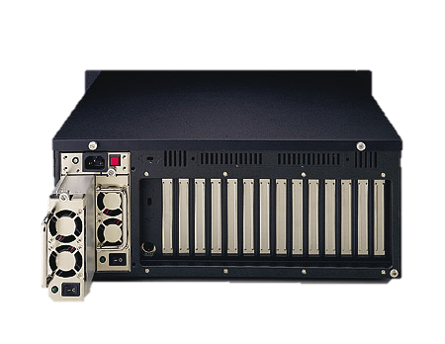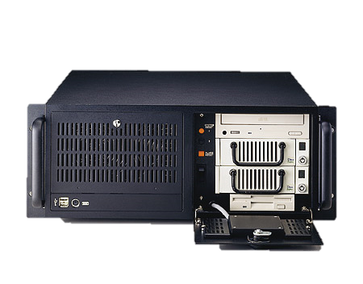

**OPTION 3**

ADVANCTECH PC industrial Fan less, with **Windows 7 64 bits.** Computer **minimum** requirements are listed below

* UNO-3285G
* CPU Processor 6th Generation Intel® Core™ i5/i7 Processor
* 8 Gb Minimum
* **Windows 7 Professional English 64bit (Includes Windows 10 Pro License)**
* Solid state SATA III Internal SSD 128 Gb (2x if RAID is required)

[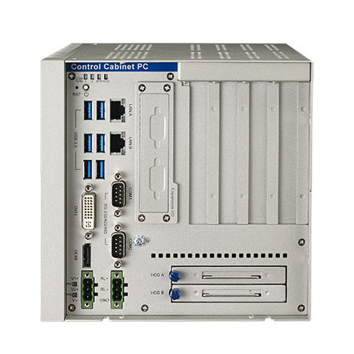](http://www.google.com/url?sa=i&rct=j&q=&esrc=s&source=images&cd=&ved=0ahUKEwjqy9uNxd_ZAhXHaRQKHUOZDwMQjRwIBg&url=http://www.advantech.com/products/1-2mljdc/uno-3285g/mod_5983b91a-c8df-4feb-a458-e7120a40be7d&psig=AOvVaw0MV8lxor-zw7wkjeMwtH5l&ust=1520695155171677)

**NOTE: Solid state disk shall be configured in RAID 1 Redundant Format if required. Window shall be installed originally in English language.**

## MECHANICAL DESIGN.

* + - The layout of the workstation should provide easy access for maintenance, oiling, cleaning, housekeeping, material handling, be especially careful with the positions of the cylinder’s sensors, shall be located for easy access to be adjusted, etc.
    - All sensors indicators shall be visible
    - All upper tools in the automatic stations shall be considered with changeover system. Changeover within 10 minutes’ maximum.
    - If technically possible, maintenance-free components shall be used.
    - Pneumatic cylinders not to carry loads different than axial.
    - Machine tool surface which meet with the work piece or surfaces which might be source of contamination shall not be painted. All heat treat equipment surfaces exposed to high temperature shall be painted with heat resistant paint.
    - Everything wearing parts shall be built using hardened tool steel.
    - All metal parts shall be treated (anodizing, zinc, hardened, black oxide, etc.) depending on material.

Any Deviation will be allowed when necessary agreed upon in writing by Manufacturing Engineer.

## PNEUMATICS.

* + - All pneumatics components will be SMC brand name (cylinders, connectors, valves, service unit, hoses, etc.).
    - Use only METRIC sized components (hoses, connectors, etc.)
    - All solenoid valves shall operate using 24 VDC.
    - Non-lubricated compressed air shall be used wherever possible.
    - Pneumatic circuit should be designed to function at 85 PSI.
    - All air cylinders that bottom in rapid travel shall be cushioned to prevent pounding. Deceleration valve shall be used when cylinders does not bottom in either direction.
    - Air discharge to atmosphere shall be provided with mufflers of sufficient capacity to reduce noise reading to 80 dBA or less at point of discharge.
    - The main air inlet valve should provide a quick means of shutting off the supply and exhausting the downstream system. It shall be in easy reach of the operator. Use **SMC** **AV2000/3000/4000/5000 Series, Soft Start-up Valve Series**
    - System to be provided with service unit: filter, pressure regulator, gage and lubricator and have easy access for maintenance personnel. Use **SMC** **ACG20~40 (FRL), Air Filter, Regulator w/Built-in Pressure Gauge, Lubricator Series**
    - All hoses to be properly routed and identified as pneumatic schematic diagram.
    - All pneumatic components to be located out of electrical enclosures. Hose connectors only plug-in type (quick-connection).
    - All connections to fixture shall be done using the following quick-type connector:

Multi-connector SMC Pneumatics, Model: KDM10-04

All pressure gages shall be electronic type, and indicator should be facing to front of the machine and been visible, even they are located under the table top.

* + - Main air inlet valve shall be solenoid controlled and hardwired to the safety circuit and machine MCR.

Deviations will be allowed when necessary agreed upon in writing by Manufacturing Engineer.

## ELECTRICAL

* + - A functional plan describing sequential operation shall be provided. This can be done in different ways as flow chart, movement’s diagrams, etc.
    - Machine voltage shall be 115 VAC single phase or 480 VAC 3 phase, 60 Hz and control voltage shall be regulated 24 VDC. Receptacles for 115 VAC shall be standard US grounded 3 prong.
    - A 4-outlet box, placed on back of the machine, is used for electrical interconnection. This box connects to the main power line. Shall be standard US grounded 3 prong. This cabinet contains the electrical, pneumatic, sensors devices.
    - Operation modes to be: Automatic mode, Manual mode, step by step-operation and one cycle run.
    - Shall be present a light totem: green light (machine in automatic mode), red light (anomaly and emergency), yellow light (step-by step, manual and one cycle run modes), buzzer (activated by a button present in the front panel and activated by the operator for intervention request).
    - Shall be present lights in the front panel for work piece status: green (good part) and red (scrap part).
    - **Expansion capacity.** Electrical panels to be designed with 30% expansion capacity in each component area (fuses, wires, etc.). Transformers and power supplies shall have 30% excess capacity. Same excess capacity for wire ways/conduits. Electrical cabinet shall have 30% Input and Output excess capacity installed (this means I/O outputs modules). A minimum of 15% spare wire shall exist in each wire way that is external to an enclosure.
    - **Wires** shall be labeled, terminated and identified as in the electrical prints (both ends). Splicing is prohibited (if applies). Wiring should run uninterrupted from terminal to terminal. All wiring shall be properly routed and contained into wire ways (if it is feasible wire ways should be placed inside enclosures). Terminals shall be crimped for all wirings. **Follow NFPA 79 Electrical Standard for Industrial Machinery Norms.**
    - All light barriers shall be Keyence brand.
    - All safety devices and relays shall be Phoenix Contact brand. (Interlocks shall be HONEYWELL)
    - All inductive, photoelectric, magnetic, etc. sensors shall be plug-in type and LED display and protected against damage.
    - All power supplies shall be PHOENIX CONTACT brand.
    - Push buttons, selectors, indicating lights, etc. shall be Allen Bradley Brand, 22mm
    - All connections to fixture shall be done using a quick-type connector.
    - Control panel shall have at least the following:
* Switch for manual/automatic mode
* Push button/light for power on (white)
* Reset key switch
* Three color Led indicator for status (red/yellow/green)
* Buzzer
* Button for activation of master cycle (using master)
* Button for activation of calibration cycle (using master)
* E-stop push button A&B 800T-FXMQ10RA7 (example)

**NOTE: Follow NFPA 79 for Color Codes,** <https://www.nfpa.org/codes-and-standards/all-codes-and-standards/list-of-codes-and-standards/detail?code=79>

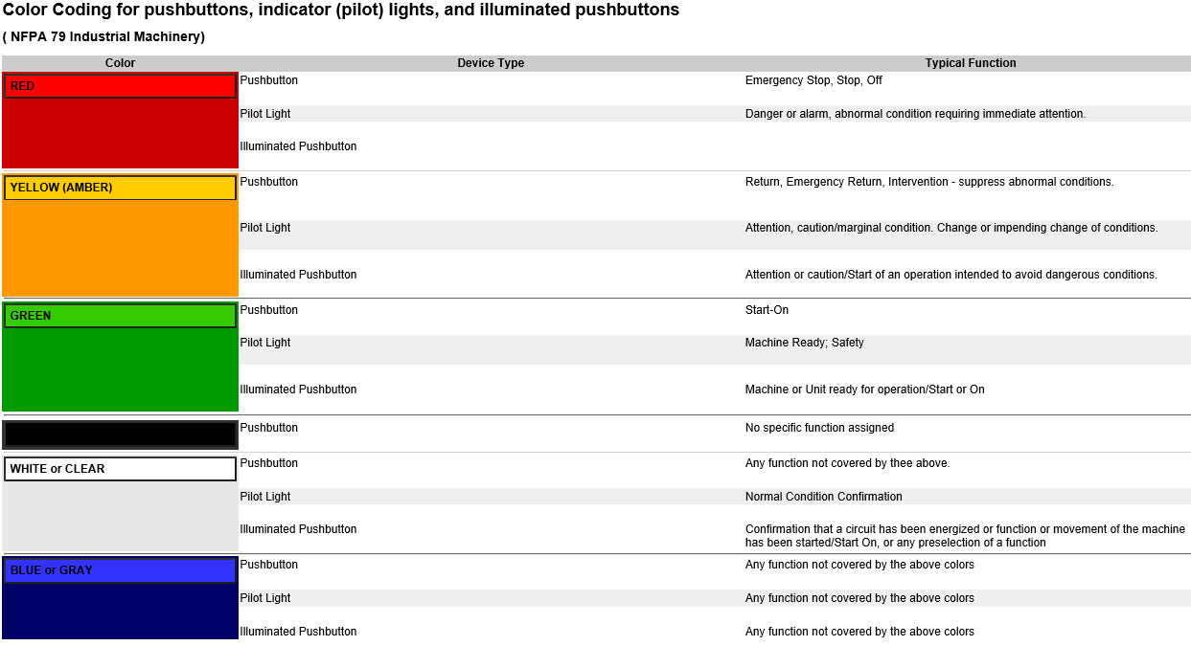

Other components:

* **Bar code readers to read Switch Housing QR for all models to be processed. Number and positions of bar code readers shall be accordingly to all the models to be processed.**
* **Use a HONEYWELL, COGNEX or KEYENCE Ethernet Bar Code Reader for part identification (launch of dedicated program after part identification). Bar code reader type shall be with auto focus lens.**
* Motors – Kollmorgen, Siemens, Baldor
* Proximity - Balluff, Sick
* Pneumatic components - Smc
* Electrical components - Allen Bradley, Balluf, Sick, Banner
* PC industrial - Advantech
* Use APC BE850M2 850 VA 450 Watts 9 Outlets UPS for PC and Monitor Battery Backup
* Digital I/O and Analogical I/O modules shall be National Instruments or PLC compatible
* Option PLC and HMI - Allen Bradley
* Opto touch button for activate the automatic cycle shall be Banner OTBVP6QD W/Y
* **Turn key for scrap restore**
* **In the SW development, shall be considered a routine for scrap restore**

**Highlight preferential brands:**

**Imagen relacionada**

Deviations will be allowed when necessary agreed upon in writing by Manufacturing Engineer

## PLC, DEVICES AND SOFTWARE.

* Programmable Logic Controller PLC shall be Allen Bradley Brand (5000 Series is preferred)
* All PLC’s outputs shall be relay type and shall have individual circuit over-current protection.
* All functional and electrical components shall be permanently labeled, same printed font type and covered with plastic, with their corresponding schematic designation.
* The machinery operated by computer shall have a backup power supply to protect the equipment from electrical blackouts, and allow for safe shutdown.
* Programming storing capacity (up to 30).
* All PLC’s outputs shall be relay type and shall have individual circuit over-current protection.
* All functional and electrical components shall be permanently plastic labeled with their corresponding schematic designation in PLASTIC HOLDERS.
* Communication PC-Scanners shall be Ethernet mode
* Use a switch for Ethernet Linksys LGS528 28-Port Managed Business Gigabit Switch
* **Software development shall be using LabVIEW or Visual Studio.**
* Ethernet connectivity available
* Software shall include Generate data report (in Excel file)
* Automatic calculate statistics of the production measurements (FPY, capability values, production measurement data, etc.)
* Data store system shall be SQL
* Shall store data of all measurements of all parts (all data shall be correlated to the part ID QR information)
* Traceability Software Integration (If Apply)
* **Software will be developed in LabVIEW or Visual Studio (PLC will be used to specifics routines and as security device controlled by main program via TCP/IP Protocol Communication.**

Deviations will be allowed when necessary agreed upon in writing by Manufacturing Engineer.

## ERGONOMICS SAFETY AND HEALTH.

* + - Equipment shall be designed to accept lockout devices on all energy sources (i.e. pneumatic, electrical, etc.).
    - All steady state or cyclical noise levels produced by machinery shall not exceed 80dB (A), when running under all anticipated operating conditions while producing parts.
    - Emergency controls shall be provided. Unless otherwise specified, the emergency button shall stop all the actuators and keep them in the position they were at this moment.
    - Appropriate guards shall be provided for all movable machinery components.
    - Some specific applications may require the safety feature of shutting down the machine if safety guard is removed. Please use common sense.
    - Warning labels shall be provided at least on the following places: voltage and gas supply, heating areas, hot surfaces, automatic operation mode, etc.
    - Lighting level for the work station shall to be 1185 Lux +/- 110 at table surface.
    - Use light barrier as brand use Keyence.

For more details follow the HSE Check List attached onto file **HES Impact Check List**

Deviations will be allowed when necessary agreed upon in writing by Manufacturing Engineer

# Actually test procedure

To propose the system to improve the Hour Meter Test is essential understand the procedure recommended by the supplier. The supplier’s procedure is the basis of the system proposed, with some modifications a test system can be implemented, as an example the oscilloscope would be replaced by a microcontroller board which can de measure the time between the rising edge of the power supply and the rising edge of the mosfet’s gate signal.

The supplier’s test procedure is listed is described below in the following lines.

## Equipment List

* Adjustable Voltage Power Supply.
* SPST Switch
* 2 Channel Digital Storage Scope.
* PCB assembly
  1. **Connection Setup.**

1. Connect positive output of Power Supply to one side of switch.
2. Connect other side of switch to the positive terminal of the PCB assembly.
3. Connect the negative output of Power Supply to negative (GND) terminal of PCB assembly.
4. Connect Channel 1 of scope probe to pin 1(VDD) of IC and ground of probe to (GND) of PCB assembly.

Connect Channel 2 of scope probe to pin 8(OUT) of IC and ground of probe to (GND) of PCB assembly

Figure 1 shows the electrical connections of the test proposed.

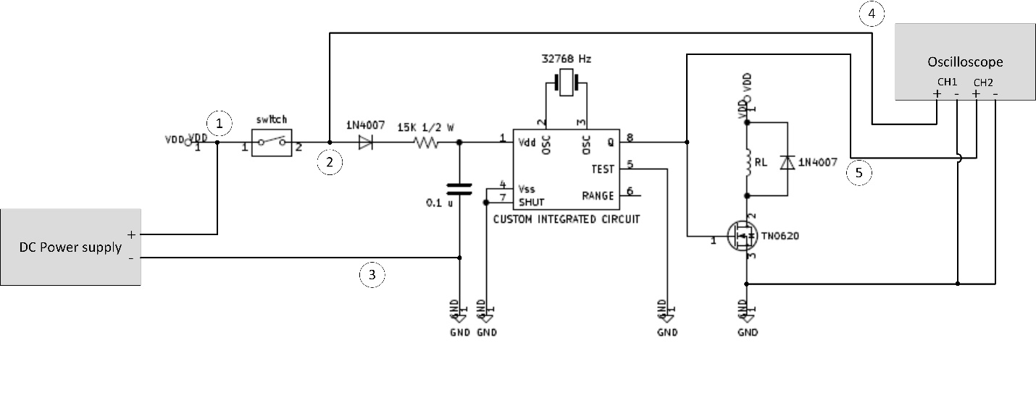

* 1. **Scope and Power Supply Setup**

1. Set Channel 1 and Channel 2 Gain to 2V/div
2. Set Scope to trigger on rising edge of Channel 1.
3. Set Scope time sweep to 400ms or 1 sec / div.
4. Set Scope to Normal and Single Trigger mode.
5. Adjust Power supply to the voltage required.
   1. **Test steps**.
6. Set Switch to OPEN position.
7. Wait a minimum of 10 sec.
8. Set Switch to CLOSED position.
9. Wait for Scope to finish sweep.
10. Measure time from rising edge of Channel 1 to Rising Edge of Channel 2 this is the first pulse start time.
11. Repeat 1 – 5 as needed.

**4.0 TEST PROPORSAL AT 1ST TEST**

In *Figure 2* is observed a schematic with the elements to enable the electrical test to measure the time in the PCB board. To explain the idea, some points must be remarked and understood in the *Figure 2*.

1. Power switch: This switch is used to enable the power in the PCB. A relay is a good and economical option to enable the power switch. Another option to be used as power switch is a MOSFET, this device has a high-speed response, but the operation as a high switch driver is more complex in comparation with an electromechanical relay.
2. Input Power Node: In this node, the voltage in the power supply is sampled and measured with help of a voltage sensor. The voltage sensor can be implemented with a voltage divider. The rising edge of the voltage in this pin can indicate the start of the operation of the IC.
3. IC Power Supply Node: This node is connected to the input power of the IC, this is marked as pin 1 in the IC datasheet. The voltage in this pin would be measured with a voltage sensor such as a voltage divider.
4. Enable Gate Mosfet Node: When the IC reaches the time of 3.6 s (10,000 hours rage) or 36 s (100,000 hours range), a high pulse is generated in the pin 8. The rising edge of the first pulse in this pin indicates the start counting in the hour meter. The difference in time with respect to the rising edge of the node D, is the time delay in the start-up of the hour meter, which must be not greater than 4 s for the (10,000-hour range). For the 100,000-hour range, the first pulse is expected in a time not greater than 36.5 s.
5. Signal Amplifier: The signal amplifier scales the voltage measured in pin 1, this amplifier is required to adequate the voltage to the ADC of the microcontroller or the acquisition board.
6. Level Shifter of the Power Input: Typically, the voltage at the power input is from 10 V to 32 V, this voltage level is not supported by the standard digital systems. In this sense, is required translate the voltage in pin 1 to TTL or CMOS levels, typically voltages of 3.3 V are used in the digital inputs of commercial microcontrollers. The rising edge in the power input can be considered as the rising edge of a digital signal, with a level shifter this can be translated to a CMOS or TTL level. The rising edge at the output in this level shifter indicates the start of operation of the hour meter.
7. Level Shifter of the Enable Gate Mosfet: As in the case F, the voltage in the pin 8 of the IC will be translated to CMOS or TTL level. The rising edge in the enable gate mosfet pin can be considered as the rising edge of a digital signal, with a level shifter this can be translated to a CMOS or TTL level. The rising edge at the output in this level shifter indicates the rising edge of the gate Mosfet pulse.
8. Switch Driver: To enable the power to the IC, a switch is used as is indicated in A, a buffer is required to adequate the signal output of the microcontroller or the acquisition board to close the switch indicated in A. In case of a relay, a Mosfet or a bjt transistor would be used as a driver. If the switch is implemented with a mosfet, a high switch is required to enable the conduction in the mosfet.
9. Microcontroller Unit: A digital system must be used to count the time between the digital signals generated in F and G. The rising edge of the signal at the output in F starts a counter in the microcontroller and when the rising edge of the signal at the output in G appears, the counter can be stopped. The microcontroller must be having input capture capability to rising edge signals.

The steps to measure the time startup of the PCB could be described with the next algorithm:

1. The microcontroller sends a digital signal to close the switch in A.
2. The rising edge of the voltage signal in B is translated to CMOS/TTL in F.
3. The output in F, is detected by the input capture 1 of the microcontroller.
4. The MCU starts a counter/timer.
5. The rising edge of the voltage signal in D is translated to CMOS/TTL in G.
6. The output in G, is detected by the input capture 2 of the microcontroller.
7. The MCU stops the counter/timer.
8. The MCU calculates the time elapsed.
9. The steps from 1 to 8 can be repeated as is required.

An additional test can be performed to measure the clocking time between the successive pulses of the Enable Gate Mosfet, in this way can be obtained a measure of the period of the clocking time. The Input Capture module of the microcontroller typically is linked to timer modules in the most commercial microcontrollers.

To measure the delay time, a commercial microcontroller or an acquisition board can be used. The Input Capture module of the microcontroller typically is linked to timer modules in the most commercial microcontrollers, this can be used to start/stop the timer in this application. A recommended microcontroller would be STM32 of ST Microelectronics.

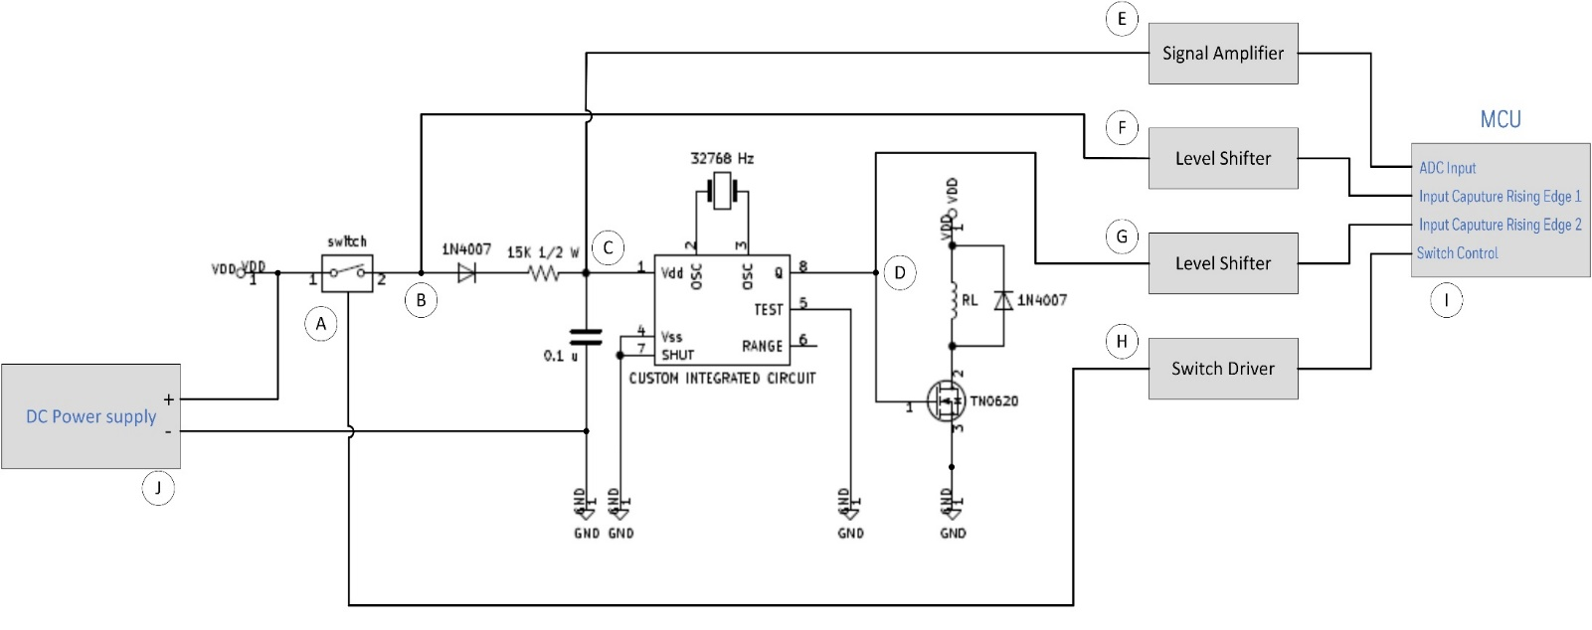

Figure 2 Diagram of the test proposal at PCB level

* 1. **TEST PROPOSAL FOR CLOSED PRODUCT (FINISH GOOD)**

This method is like the proposal explained in the second part of this document, the difference is that is not required to disassembly the finish good to extract the PCB. In *Figure 3*, the box in dashed red represents the hour meter as finish good, in this image can be appreciated that the measure points are out side of the finish good. Typically, the current consumption of the board with the pin 8 at low level (0 V) is less than 50 mA, this can be considered as a low current state. When the voltage at pin 8 is high (it means the gate mosfet is enabled), the coil of the relay is drawing a current and, in this way, the current in the power input is greater than 200 mA, the rising edge of this current can be used to detect the threshold voltage of a digital signal. A signal generated with help of some comparators could me detected by the input capture modules of the microcontroller, this can lead to measure the time with a timer/counter. *Figure 3* is explained below:

1. Power switch: This switch is used to enable the power in the PCB. A relay is a good and economical option to enable the power switch. Another option to be used as power switch is a MOSFET, this device has a high-speed response, but the operation as a high switch driver is more complex in comparation with an electromechanical relay.
2. Input Power Node: In this node, the voltage in the power supply is sampled and measured with help of a voltage sensor. The voltage sensor can be implemented with a voltage divider. The rising edge of the voltage in this pin can indicate the start of the operation of the IC.
3. Current Sensor: The current consumed by the hour meter is monitored or measured by a current sensor. This output of this sensor is connected to the input of a comparator which process the signal.
4. Voltage Input Amplifier/Comparator: The voltage signal detected in B, is processed by a voltage comparator that generates a digital signal. The signal at the output at D, is introduced to the Input Capture 1 of the microcontroller, in this sense, is required translate the voltage comparator signal to TTL or CMOS levels, typically voltages of 3.3 V are used in the digital inputs of commercial microcontrollers. The rising edge of the voltage comparator output can be considered as the rising edge of a digital signal and indicates the start of operation of the hour meter.
5. Current Amplifier/Comparator: The current signal detected in C, is processed by a voltage comparator that generates a digital signal. The signal at the output at E, is introduced to the Input Capture 2 of the microcontroller, in this sense, is required translate the voltage signal to TTL or CMOS levels, typically voltages of 3.3 V are used in the digital inputs of commercial microcontrollers. The rising edge in the power input can be considered as the rising edge of a digital signal, with a level shifter this can be translated to a CMOS or TTL level. The rising edge at the output in this comparator indicates the rising edge of the gate Mosfet pulse.
6. Switch Driver: To enable the power to the IC, a switch is used as is indicated in A, a buffer is required to adequate the signal output of the microcontroller or the acquisition board to close the switch indicated in A. In case of a relay, a Mosfet or a bjt transistor would be used as a driver. If the switch is implemented with a mosfet, a high switch is required to enable the conduction in the mosfet.
7. Microcontroller Unit: A digital system must be used to count the time between the digital signals generated in F and G. The rising edge of the signal at the output in F starts a counter in the microcontroller and when the rising edge of the signal at the output in G appears, the counter can be stopped. The microcontroller must be having input capture capability to rising edge signals.

The steps to measure the time startup of the PCB could be described with the next algorithm:

1. The microcontroller sends a digital signal to close the switch in A.
2. The rising edge of the voltage signal in B is translated to CMOS/TTL in D.
3. The output in D, is detected by the input capture 1 of the microcontroller.
4. The MCU starts a counter/timer.
5. The rising edge of the current signal in C is translated to CMOS/TTL in E.
6. The output in E, is detected by the input capture 2 of the microcontroller.
7. The MCU stops the counter/timer.
8. The MCU calculates the time elapsed.
9. The steps from 1 to 8 can be repeated as is required.

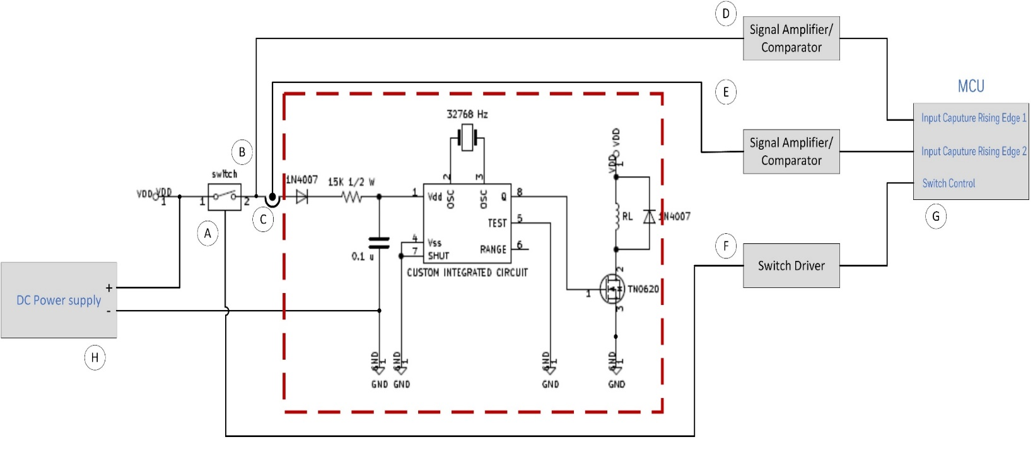

Figure 3 Diagram of the test proposal at final assembly level.